**Lab 8 Exercise**

1. Two new flights are scheduled to leave from *BOS* to *ORD* airports.
   * The first flight (*flightId 1111*) will be on airplane *AP098640* departing on-time at 2018-11-05 12:00:00 and arriving on-time at 2018-11-05 14:30:00.
   * The second flight (*flightId 1112*) will be on airplane *AP432379* departing on-time at 2018-11-05 22:00:00 and arriving on-time at 2018-11-06 00:30:00.

**Transaction Query:**

SET XACT_ABORT ON

BEGIN TRANSACTION flightAddition

INSERT INTO FlightRoute_t VALUES ('1111','BOS','ORD','12:00','14:30')

INSERT INTO FlightSchedule_t VALUES ('1111','2018-11-05','O','AP098640', NULL,NULL);

INSERT INTO FlightRoute_t VALUES ('1112','BOS','ORD','22:00','00:30')

INSERT INTO FlightSchedule_t VALUES ('1112','2018-11-05','O','AP432379', NULL,NULL);

COMMIT TRANSACTION flightAddition

**Select Query 1:**

SELECT * FROM FlightRoute_t WHERE flightNumber IN ('1111','1112');

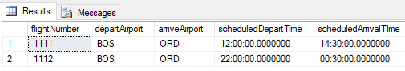

**Select Query 2:**

SELECT * FROM FlightSchedule_t WHERE flightNumber IN ('1111','1112');

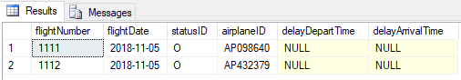

1. Due to forecasted inclement weather, the new flights’ **statuses** have changed.
   * The earlier new flight from *BOS* to *ORD (flightId 1111)* has been ***delayed*** by 10 hours.
   * The later new flight from *BOS* to *ORD (flightId 1112)* hasbeen ***canceled***.

**Transaction Query:**

SET XACT_ABORT ON

BEGIN TRANSACTION flightupdate

UPDATE FlightSchedule_t

SET statusID='D', delayDepartTime='22:00',delayArrivalTime='00:30'

WHERE flightNumber = '1111'

UPDATE FlightSchedule_t

SET statusID='C'

WHERE flightNumber='1112';

**Select Query:**

SELECT * FROM FlightSchedule_t WHERE flightNumber IN ('1111','1112');

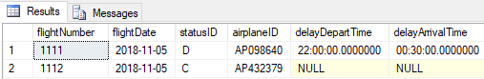

1. The weather has improved and the two flight are back to the original statuses (*question 1*).
   * ROLLBACK the last transaction (2)

**Rollback Query:**

ROLLBACK TRANSACTION flightupdate;

**Select Query:**

SELECT * FROM FlightSchedule_t WHERE flightNumber IN('1111','1112');

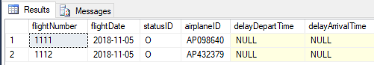

1. There is a new flightRoute between Portland, OR (*cityID C010*) and Seattle, WA (*cityID C011*).
   * The Portland airport is airportId *PDX* and is named *Portland International Airport*.
   * The Seattle airport is airportId *SEA* and is named *Seattle–Tacoma International Airport*.
   * The flight from PDX to SEA *(flightID 1003*) is scheduled to depart at *08:00:00 and arrive at 09:15:00.*
   * The flight from SEA to PDX (*flightID 1004*) is scheduled to depart at *14:00:00 and arrive at 15:15:00*.

**Transaction Query:**

SET XACT_ABORT ON

BEGIN TRANSACTION flightAddition2

INSERT INTO states_t VALUES ('OR','Oregon')

INSERT INTO City_t VALUES ('C010','OR','Portland')

INSERT INTO Airport_t VALUES ('PDX','C010','Portland International Airport')

INSERT INTO states_t VALUES ('WA','Washington')

INSERT INTO City_t VALUES ('C011','WA','Seattle')

INSERT INTO Airport_t VALUES ('SEA','C011','Seattle–Tacoma International Airport')

INSERT INTO FlightRoute_t VALUES ('1003','PDX','SEA','08:00','09:15')

INSERT INTO FlightRoute_t VALUES ('1004','SEA','PDX','14:00','15:15')

COMMIT

**Select Query 1:**

SELECT * FROM states_t WHERE stateAbbr IN ('OR','WA');

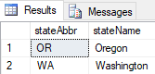

**Select Query 2:**

SELECT * FROM City_t WHERE stateAbbr IN ('OR','WA');

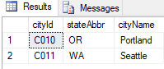

**Select Query 3:**

SELECT * FROM Airport_t WHERE cityId IN ('C010','C011');

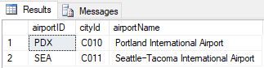

**Select Query 4:**

SELECT * FROM FlightRoute_t WHERE flightNumber IN ('1003','1004');

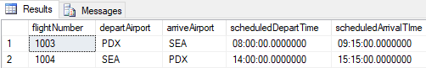

1. An operations analyst is interested in understanding flight capacity at each airport. In order to do so, they need to continually monitor how many departing and arriving flights occur at each airport.

To assist the analyst, create a **VIEW** called *Airport_Capacity* with the following columns:

* *airportId, airportName, cityId, cityName, stateAbbr, StateName*
* View contains the total number of departing and arriving flights for each airport
* The view **excludes** airports which have no departing and arriving flights

**Create View Query:**

CREATE VIEW Airport_Capacity AS

SELECT a.airportID, x.AirportName,c.cityId, cityName, s.stateAbbr, s.StateName, departCount, arriveCount

FROM

(SELECT COUNT(flightNumber) AS departCount, departAirport AS AirportName FROM FlightRoute_t GROUP BY departAirport) AS x

INNER JOIN

(SELECT COUNT(flightNumber) AS arriveCount, arriveAirport AS AirportName FROM FlightRoute_t GROUP BY arriveAirport ) AS y

ON x.AirportName = y.AirportName

INNER JOIN Airport_t a ON a.airportID = x.AirportName

INNER JOIN City_t c ON a.cityId = c.cityId

INNER JOIN states_t s ON c.stateAbbr = s.stateAbbr

WHERE NOT (departCount = 0 and arriveCount = 0)

**Select Query:**

SELECT * FROM Airport_Capacity

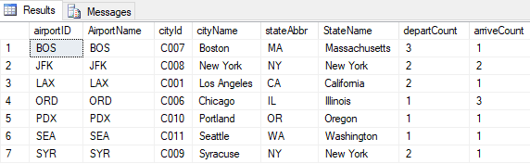

1. Query the *Airport_Capacity* view and return the distinct states (*DISTINCT stateAbbr*) where the number of departures is greater than or equal to the number of arrivals.

**Select Query:**

SELECT DISTINCT stateAbbr FROM Airport_Capacity WHERE departCount >= arriveCount

